**Chapter 6: x86 HARDWARE COMPONENTS**

**Topic – 13: Components Of x86 Computers**

**Motherboard Components**

* CPU
* Supporting processors (chipset)
* Main memory
* I/O connectors
* Power supply connectors
* Expansion slots

***\*These components are connected to each other using bus (wires)\****

**Expected Components**

* CPU socket
* Memory slots (plug-in memory boards)
* BIOS (contains system software)
* CMOS RAM (with circular battery)
* Large storage device connectors (like HDD, CD-ROMs etc)
* USB connectors
* Keyboard & mouse ports
* PCI board connectors (for sound card & graphic card etc)

**Optional Components**

* Sound processor
* Parallel & serial device connectors
* Network adapter
* AGP bus connector (for high-speed video card)

**Important Supporting Processors**

* **Floating-point unit (FPU)**
* **8284/82C284 clock generator –** Syncs CPU & whole computer.
* **8259A Programmable interrupt controller (PIC) –** Handles external interrupts like keyboard, system clock & hard drive.
* **8253 Programmable interface timer/counter –** Interrupts CPU 18.2 times each second to update date & time of system. Also responsible for refreshing memory because RAM can’t keep its data for more than few milliseconds.
* **8255 Programmable parallel port –** Transfers data from memory using IEEE parallel ports, they are used in devices like printers.

**PCI Express Bus Architecture**

* **PCI** stands for ***peripheral component interconnect***.
* **PCI** establishes a connection between **CPU** & **other** hardware devices.
* These devices can be **hard disks**, **memory**, **network controllers** etc.
* Recent **PCIs** provide **bidirectional connections** between CPU, memory & devices.
* And they also **transfer data** in packets in **separate lanes**, at **high speeds**.

**Motherboard Chipset**

* **Motherboard chipset:** Set of chips embedded on particular type of motherboard.
* Intel **P965** is used with **Intel Core 2 Duo** or **Pentium D**.

**Features of Intel P965**

* Fast memory access uses ***memory controller hub*** (**MCH**).
* **MCH** can access **dual-channel** **DDR2** memory at **800 MHz** clock speed.
* An I/O controller hub like **Intel ICH8/R/DH** uses Intel’s **matrix storage technology** (**MST**) to support multiple hard disks.
* Supports multiple **USB ports**, **PCI express slots**, **networking** etc.
* Also has an **HD** sound chip.

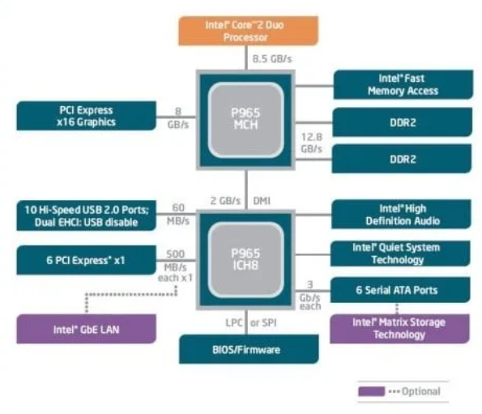

**Topic – 14: Memory**

**Introduction**

* Types of memory used in Intel system are **ROM**, **EPROM**, **DRAM**, **SRAM**, **VRAM** & **CMOS** **RAM**.

**EPROM**

* Can be erased with **ultraviolet light**.

**DRAM**

* Also known as **main memory**.
* Stores data of **running programs**.
* Refreshed **every** **millisecond**.
* Some systems may use **ECC** (**error checking & correcting**) **memory** instead.

**SRAM**

* High speed cache memory.
* Expensive.

**VRAM**

* Dual-ported.
* One port **writes data** to display.
* Another port **refreshes the display** using that data.

**CMOS RAM**

* **CMOS RAM** stands for **Complimentary metal oxide semiconductor RAM**.
* Contains **system setup information** & hence **doesn’t** lose its content even when powered off.
* Refreshed using **system battery**.

**Topic – 15: Input-Output System**

**Introduction**

* We **not** necessarily need to access the hardware directly.
* This is because **OSes** provide many call functions to do so.

**Levels Of I/O Access**

* **High-level language functions:** These are functions provided by **high-level languages** to perform I/O operations.
* **Operating system:** Provides **API libraries** to perform I/O operations like writing & reading strings from files, allocating memory blocks etc.
* **BIOS:** Contains **subroutines** that directly communicate with hardware & is installed by computer manufacturer. **OSes** usually communicate with **BIOS**.

**Device Drivers**

* They allow OS to directly communicate with hardware devices.
* These devices also include **BIOS**.
* Device drivers are either **separately installed** or installed when **device is attached**.
* In the second case, first **device signature** is detected & then its **name**.

**Displaying String On Screen**

* **Step 1:** **HLL** (**high-level language**) statement **displays string** on the screen.
* **Step 2:** This function passes the **string pointer** further to an **OS function**.
* **Step 3:** This OS function further passes the **ASCII code** & **colour** of each character to a **BIOS subroutine**, using a **loop**.
* **Step 4:** Another **BIOS subroutine** is called to **advance the cursor** on screen as the characters are displayed one-by-one.
* **Step 5:** This character is then **mapped** to a **system font**.
* **Step 6:** The character is sent to a **port** attached to ***video controller card***.
* **Step 7:** **Video controller card** produces **hardware signals** to the screen which does ***raster scanning*** (lighting pixel LEDs horizontally line-by-line).

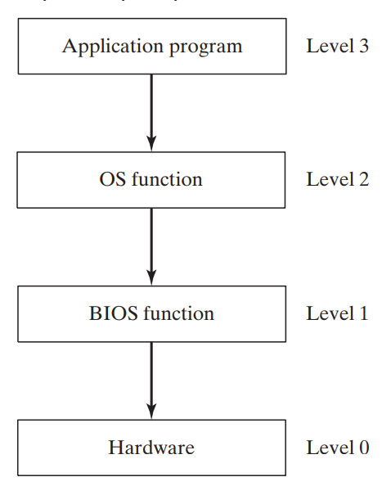

**Programming At Multiple Levels**

* **Level 3:** Using **libraries** to perform **text I/O** & **file I/O** operations.
* **Level 2:** Using **OS** to perform **text I/O** & **file I/O operations**. If an OS uses **GUI**, then it can display graphics **independent** of device.
* **Level 1:** Using **BIOS** subroutines and **manipulate** colours, graphics, sound, keyboard, disk & other hardware devices.
* **Level 0:** Receive data & specifications **directly** from hardware ports, but that makes it **unportable** because hardware like ports **may vary** across devices.

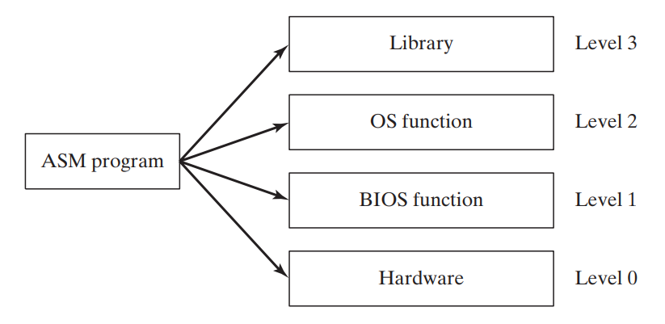

**Level 1 (BIOS)**

* Code at this level has to be different for **each system**.
* Or a programmer has to write code to **adjust** certain aspects which are **varying** across each system.
* For example, **hardware display** might be different across systems, so a programmer has to write code to adjust the **resolution** when running another system with same code.

**Level 0 (Hardware)**

* Generally, works with **generic devices**.
* **Generic devices:** Devices having many **commonness** in hardware design.
* Code at this level **directly communicates** with hardware **without** anything coming between **hardware** & **code**.
* These code needs to be modified when being **ported** to a hardware having some differences in design.
* Early video games were written at this level & thus had **full control** over the hardware.

**More Insights**

* At **BIOS level**, we can interact with hardware components directly.
* For example, we can communicate with **sound card** using its **device driver software** installed in **BIOS**.
* We can find out what **class** it belongs to & can even **fine tune** its performance as per its features for our needs.
* Though **not** many cards allow to make changes to its program.
* Most general-purpose OSes **don’t** allow users to directly access hardware in order to **avoid** making serious accidents with system.
* There are some OSes that are made for **specific devices** which directly interact with hardware, in order to keep **minimal memory occupation** rather than using complete OS.
* **MS-DOS** was **last Microsoft OS** to allow direct access to hardware.
* It was a **single-task** & **single-user** OS.

**Topic – 16: Summary**

**Terminologies**

* **BIOS:** A **collection of functions** that can directly communicate with the hardware.
* **Direction flag:** Tells the direction of processing (will know more later).
* **PCI express:** High-speed interface used to connect various components to motherboard.
* **PCI:** Peripheral Component Interface
* **PIC:** Programmable Interrupt Control
* **Programmable parallel port:** Port to allow transfer of data between computer & peripheral devices.
* **SIMD:** **Single-instruction multiple-device**, allows to execute programs involving data which are physically on **different** locations.

**Clarity To Misconceptions**

* If an arithmetic operation is **too small** or **too large** as per a given number bits, then the **overflow flag** is set. There is **nothing** like **underflow flag**.
* **REX** is used to **extend** the number of available registers for our **operand**.
* On a **32-bit** system, **FPU** is of **80-bits**.
* In **64-bit** chips, **not** all **64-bits** can be used for **addressing** because some bits are **reserved**.
* **Itanium** instruction set is completely different from **x86**.
* In **64-bit** **native** mode, you can use **16-bit real** mode but not **virtual-8086** mode.
* **x86-64** processors have more GPR than **x86** processors, like **R8**, **R9**, **R10** etc.
* Directly providing sound outputs to sound card ports can also **enhance audio quality**.